**\*\*\***

**Fundzforus Beta Release Requirements**

**\*\*\***

1. **Purpose and Scope**

This document serves the purpose of outlining all the requirements set for the beta release of the application to be developed for J Cruz Group LLC. The scope of this document is only limited to the outlined requirements.

Additional necessary revisions will be made for each release as set by J Cruz Group LLC.

1. **Product Overview and Uses**

Application “Fundzforus” will be an Android/iOS/Web-app based cross-platform. The application is intended to be a tenant onboard able platform connecting its end users to critical resources hosted by their tenants. CRM integration remains the key component for operational functionality on the app to maintain its tenants. The application code will be hosted in Google Cloud and will make use of optimized services and resources.

1. **Requirements** (technical, environmental, functional, support requirements, etc.)

The code will be developed using Node JS/Java Spring boot for the backend and for front end Angular/React JS will be used. Google Cloud environments best suits the requirements as it provides added security features. There will be an additional Android/iOS licensing cost for hosting the application. We will also require all the necessary source files to be used for UI design.

Following screenshots best describe the beta release requirements.

|  |
| --- |
| Login screen  This screen will make use of Facebook/Email/Google Accounts to sign up/login to their page. |

1. Login screen

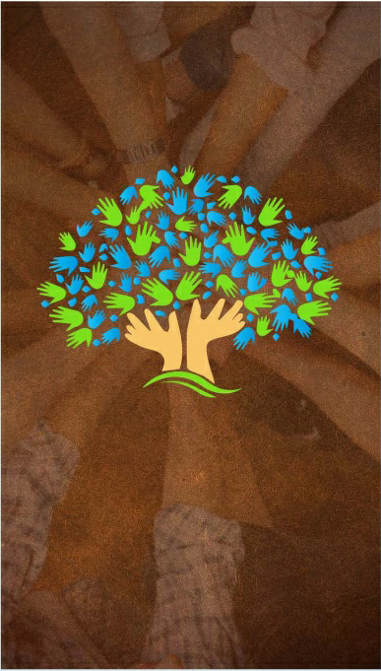

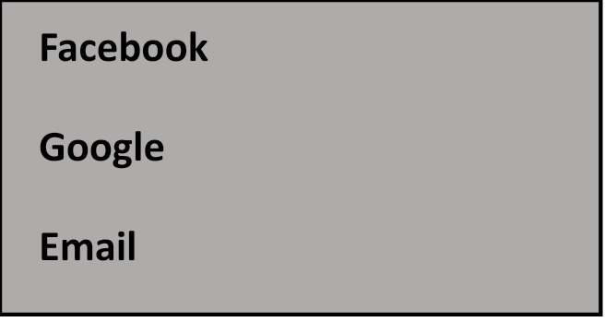

1. Home screen

|  |
| --- |
| Home screen  This is the screen users will see after the login.  Following screens will further display more navigation options |

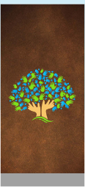

1. Left menu screen

|  |
| --- |
| Left menu screen  This screen lists all the sub-pages to be used by end users to navigate to the partners page, access message boards, video pages hosted in Google Cloud and the programs offered by the tenants. |

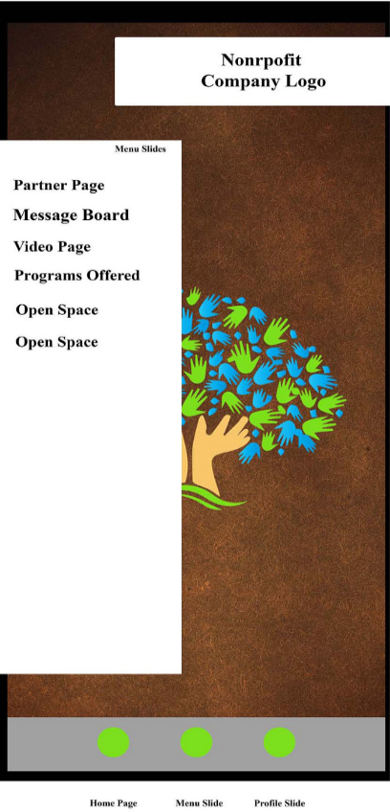

1. Right menu screen

|  |
| --- |
| Right menu screen  This will be the screen for users to update their Profile pictures/display pictures and other personal information |

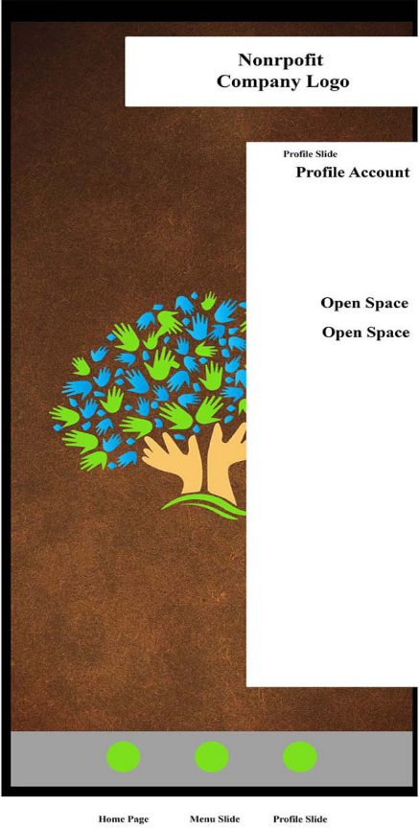

1. Partners Page

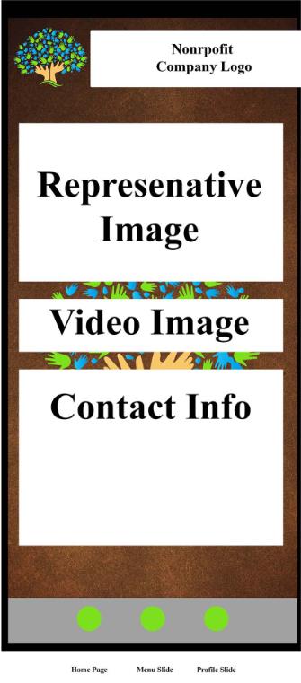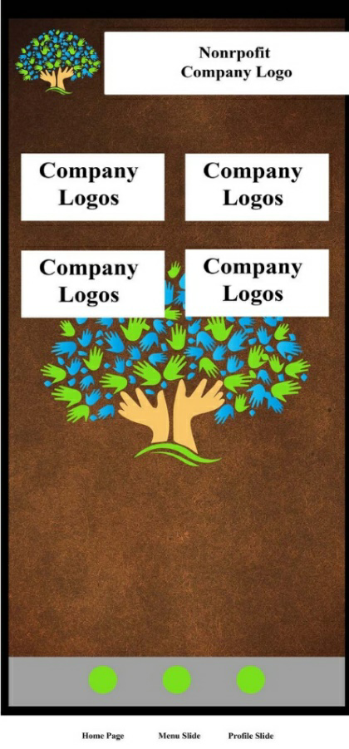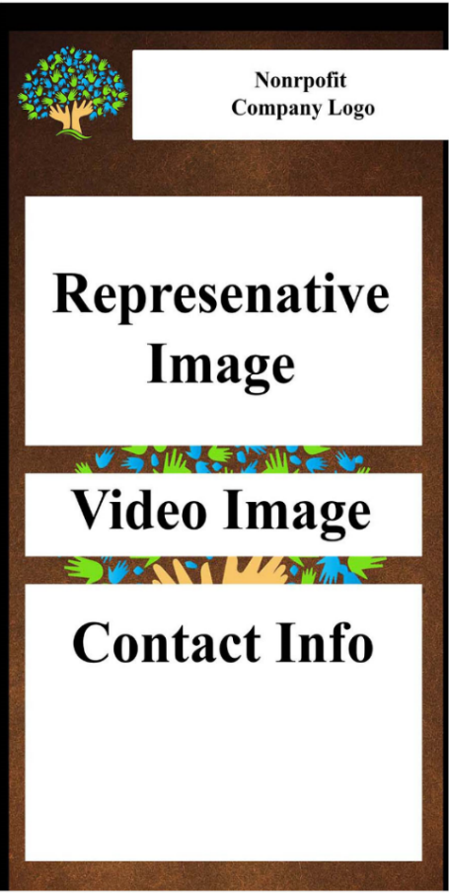

|  |
| --- |
| Partners Page  This will be the screen for users to get more details about the partners/tenants. This includes a profile image, video greetings and contact information.  Corresponding page shows other partners in the network and can be redirected to retrieve more information on the tenants. |

1. Video page/Programs page/Message board page

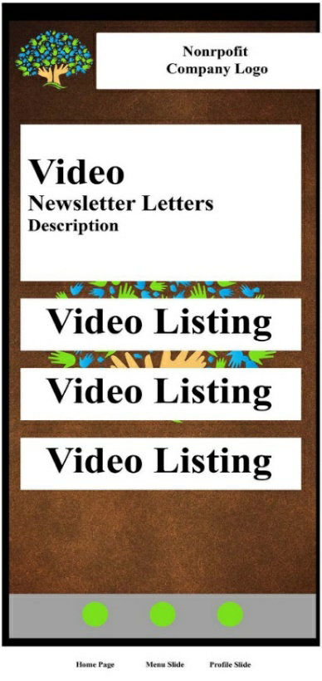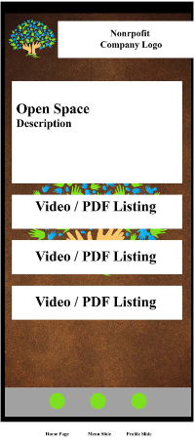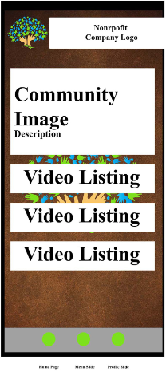

|  |
| --- |
| Video page/Programs page/Message board page  Video page is for daily/weekly news letters by the tenants, along with the content listing host in the cloud. Upon clicking the content icon, it pops up a small window to display the content.  Programs page is desired to offer various listing to the activites offered by the tenants, it could be a video or pdf type content.  Message board page is meant to provide its users with a platform/forum to receive communications from the tenants. |

1. **Workflow**

Following flows have been identified for the initial test release,

1. The initial requirements given indicate the need to have a code converted and accessible for demonstrations to be conducted by the group.
2. Google Cloud Project creation for hosting
3. Review the requirements
4. Design the framework
5. Architect the CRM integration with the application via API call
6. Develop the code
7. Penetration testing
8. Friends & Family testing
9. Test tenant onboarding
10. Beta release
11. **Evaluation Plan and Performance Metrics**

Throughout the development phase, various open source tools will be used to test the code and review performance metrics.

1. **Future Work**

We have also identified additional features that will be added to the platform with planned sprint cycles after the initial release. This will ensure smooth delivery of the feature sets over the course leading to the final release.

1. **Admin**

* There are two types of admins in this app, one is tenant admin and another Super admin.
* Super admin shall have a full access to control the system, super user shall have ability to do below functions:
* Super user shall have ability to login using Local/Facebook/google.
* Will have Use 2 factor authentication for super admins.
* Super user shall have ability to switch to customer view or admin view to validate the customer end view after publishing any changes to the website or configuration.
* Super user shall have an ability to add/edit/delete tenants.
* Super user shall have an ability to view the system status, also will have an ability to bring down the complete system if its required.
* Super admin user shall have an ability to restart the system on single click.
* Super admin shall have an ability to configure the email frequency to the partners. Also, admin can manually send instant communication.
* Super admin shall have an ability to edit the email text in email template feature.

1. **Tenant admin:**

* Tenant admin shall have an ability to login/logout option on screen.
* Tenant admin shall have an ability to login using Facebook/google/local auth with two factor auth.
* Tenant admin shall have an ability to manage users for the organization.
* Tenant admin shall have an ability to update contents w.r.t to organization.
* Tenant admin shall have an ability to add / delete video contents for the organization.
* Tenant admin will have add/delete the blog or messages.
* Will have rules for the messages/blogs to get an auto approval to publish instantly and will be visible to the end user. If it will have match with predefined in the system and can hurt society and it will go for tenant approval.
* Tenant admin will have an option to approve or reject the user message.
* Communication will be sent to the requested user in both above cases.
* Tenant admin shall have an ability to update the org schedule.
* Tenant can request end users to respond on particular events if user will be able to join or not, it will help management to know how many users will be joining for that event to arrange space as per cdc guideline in covid-19 situation.
* Tenant will have access to send communication to end user related to that org to make immediate announcement.

1. **End user - Webapp/Mobile app**

* User shall have an option landing screen with logo.
* User shall have an ability to view landing screen if it’s not user.
* User shall have an option to login Facebook/google/ local to access the system.
* If its new user and it was not added by the tenants, then request will be sent to tenant after successful login.
* If user has been added by tenant, then user shall have an ability to see the organization page.
* After successful login user will have access to the video content.
* User shall have an ability to see all the available programs.
* User shall have an option to confirm the presence for the event.
* User shall have an ability to see the count on screen, to get an idea regarding crowd in upcoming event.
* User shall have an ability to get an option to enable or disable notifications.
* User shall have an ability to edit the profile to update the contact details.
* User shall have an ability view the uploaded video in this app.
* User shall have an option to select resolution as per the network bandwidth.
* User shall have option to read blogs and messages.
* User will have an option to like the videos and other contents.
* User shall have an ability to see all the partners related to the org.
* User shall have an option to request to become partner with org.

**Release 1 items: (2 weeks)**

* UX design for Mobile app.
* Back-end design and API development for Login screen.

**Release 2: (8 weeks)**

* iOS/Android mobile app
* Back end
* Infrastructure setup – development
* Web UX/UI design for customers/admin/tenant interface.

**Release 3: (4 weeks)**

* Web release – Customer
* UAT infrastructure setup

**Release 4 (4 weeks)**

* Web Portal for admins/tenants

**Release 5: (2 weeks)**

* Production deployment
* Performance testing
* Security testing- Static scan/dynamic scan

***Note: Vendor will be responsible to pay all the licenses, infrastructure, Google developer license, Apple developer licenses and tools cost during development phase.***